**EXECUTION ORDER FORM**

To order development Form based on : AR transaction

Module : Finance

Sub Module : Account Receivable

Name of Functional Specification : Interface SAP-CIS

Signed by:

< Fadia Hadyani Putri > < Fadia Hadyani Putri >

< Berry Rachmawan > < Harry Mulya >

< Integration Team Lead >

Additional Program

## General Status Information

|  |  |
| --- | --- |
| **Reference ID.** | - |
| **Spec ID** |  |
| **Priority** | After Go-Live |
| **Version** | 0.0 |
| **Business Owner** |  |
| **Description** | Interface SAP - CIS |
| **Prepared By** | Fadia Hadyani Putri |
| **Estimated Development Time** |  |
| **Date of Creation** | 05 SEPTEMBER 2022 |
| **Date (last modified)** |  |
| **T-Code** | Z22FIIxxx |

|  |
| --- |
| ***Name of Closest SAP Form*** |
|  |

|  |
| --- |
| ***Reason why not using the Standard SAP*** |
| ***KTI akan menggunakan aplikasi CIS untuk mendukung performa penyampaikan informasi atas pemakaian air per pelanggan serta informasi UJL (Uang Jaminan Langganan) yang dikenakan per pelanggan, oleh karena itu SAP akan menyesuaikan data UJL yang akan di informasikan melalui aplikasi CIS.*** |

Business Specifications and Requirements

## Business Requirements Description

Pengiriman data dari SAP diperlukan sebagai data penunjang dalam pelaporan transaksi UJL, diantaranya:

1. Pembuatan Z-Program untuk pengambilan struktur data yang dibutuhkan dalam pelaporan transaksi UJL serta di kirimkan ke *middleware*.
2. Pembuatan custom table untuk menampung struktur data pada aplikasi SAP dan dikirimkan ke aplikasi CIS melalui *middleware*.
3. Program Z22FIIxxx akan membaca data yang telah dikirim dari custom table.

## Business Requirements Specifications

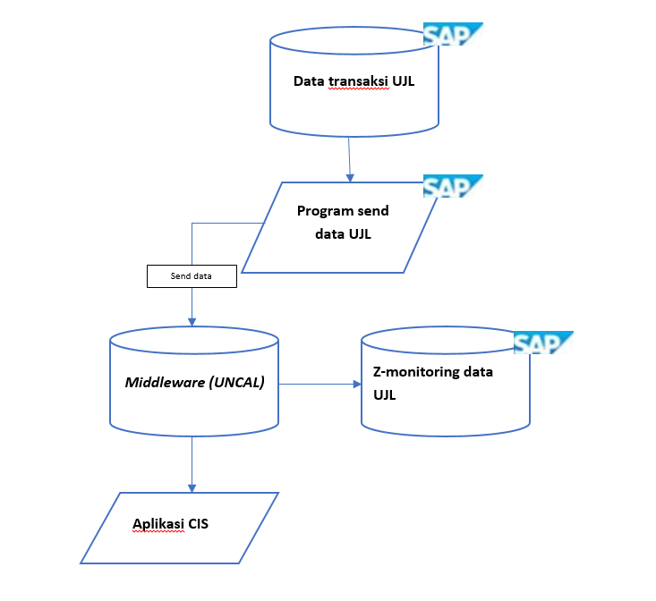

*Flow Process* sebagai berikut:

1. Seluruh transaksi UJL yang sudah terposting per pelanggan akan disimpan di program send UJL yang sudah disesuaikan *field*nya dengan aplikasi CIS.
2. Kemudian akan dikirimkan ke middleware dan sekaligus tersimpan datanya di Z-monitoring.
3. Selanjutnya middleware akan kirim data transaksi UJL ke aplikasi CIS.

Program ini harus berisi logic sbb:

1. SAP akan mengirimkan data UJL yang sebelumnya sudah terposting dan dikumpulkan dalam satu program Z.
2. Dibuatkan Z-table untuk penyamaan logic antara SAP dan aplikasi CIS.
3. Memiliki program monitoring untuk memastikan data yang dikirim dari SAP ke *middleware* sudah sesuai.

Detail Requirements Definition

## Data Dictionary Used.

| **Table Name** | Table Description | **Insert** | **Delete** | **Query** | **Update** |
| --- | --- | --- | --- | --- | --- |
| BKPF | FI Document: Header Data |  |  |  |  |
| BSEG | Accounting Document Segment |  |  |  |  |
| KNA1 | Customer General Data |  |  |  |  |
| KNB1 | Customer Company Code Data |  |  |  |  |

## Data Dictionary Used.

| **Table Name** | Table Description | **Insert** | **Delete** | **Query** | **Update** |
| --- | --- | --- | --- | --- | --- |
|  |  |  |  |  |  |
|  |  |  |  |  |  |

## Custom Data Dictionary.

|  |  |  |  |  |  |
| --- | --- | --- | --- | --- | --- |
| **Field Name** | **Description** | **Data Type** | **Length** | **Decimals** |  |
|  |  |  |  |  |  |
|  |  |  |  |  |  |
|  |  |  |  |  |  |

Selection screen design

1. Send data UJL realtime from SAP to Aplikasi CIS

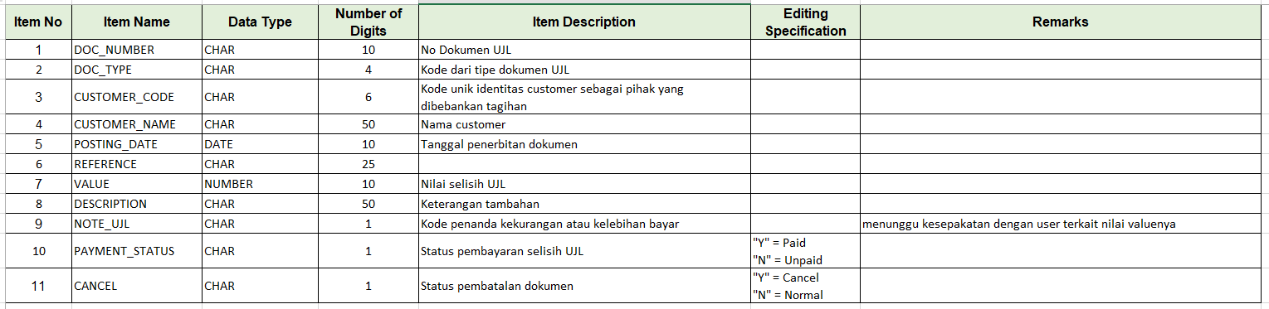

## Process details layout data UJL yang akan dikirim dari SAP ke aplikasi CIS

| **No** | **Field** | **Table-Field** | **Remarks** |
| --- | --- | --- | --- |
| 1 | DOC_NUMBER | BSEG-BELNR | Select BELNR = 040*, 18* from BSEG where HKONT = 2900303, 2900103, 1110509, 1110511, 1110510, 1110512, 2900203 |
| 2 | DOC-TYPE | BSEG-H_BLART | Select BELNR = 040*, 18* or from BSEG where HKONT = 2900303, 2900103, 1110509, 1110511, 1110510, 1110512, 2900203 get data H_BLART |
| 3 | CUSTOMER_CODE | BKPF-KUNNR | Select BELNR = 040*, 18* from BSEG where HKONT = 2900303, 2900103, 1110509, 1110511, 1110510, 1110512, 2900203, where BSCHL = 01 get data KUNNR |
| 4 | CUSTOMER_NAME | KNA1-NAME1 | 1. Select BELNR = 040*, 18* from BSEG where HKONT = 2900303, 2900103, 1110509, 1110511, 1110510, 1110512, 2900203, BSCHL = 01 get data KUNNR 2. Go to table KNB1 input KUNNR, if KUNNR registered on KNB1 BUKRS 2200 3. Then, go to table KNA1 get data NAME1 |
| 5 | POSTING_DATE | BKPF-BUDAT | Select BELNR = 040*, 18* from BKPF where BLART = UE and DR get data BUDAT |
| 6 | REFERENCE | BKPF-XBLNR | Select BELNR = 040*, 18* from BKPF where BLART = UE and DR get data XBLNR |
| 7 | VALUE | BSEG-PSWBT | Select BELNR = 040*, 18* from BSEG where HKONT = 2900303, 2900103, 1110509, 1110511, 1110510, 1110512, 2900203, UMSKZ = C, get data PSWBT |
| 8 | DESCRIPTION | BSEG-SGTXT | Select BELNR = 040*, 18* from BSEG where HKONT = 2900303, 2900103, 1110509, 1110511, 1110510, 1110512, 2900203, BSCHL = 01 get data SGTXT |
| 9 | NOTE_UJL | BKPF-BKTXT | 1. Select BELNR = 040*, 18* from BKPF where BLART = UE and DR get data BKTXT 2. If BKTXT = ‘01’ 🡪 over UJL   If BKTXT 🡪 ‘00’ 🡪 insufficient |
| 10 | PAYMENT_STATUS | BSEG-AUGBL | 1. Select BELNR = 040*, 18* or H_BLART = UE and DR from BSEG where HKONT = 2900303, 2900103, 1110509, 1110511, 1110510, 1110512, 2900203, BSCHL = 01 2. If AUGBL = 14* 🡪 ‘Y’ (Y means PAID)   If AUGBL = blank 🡪 ‘N’ (means UNPAID) |
| 11 | CANCEL | BSEG-AUGBL | 1. Select BELNR = 040*, 18* or H_BLART = UE and DR from BSEG where HKONT = 2900303, 2900103, 1110509, 1110511, 1110510, 1110512, 2900203, BSCHL = 01 2. If AUGBL = 16* 🡪 ‘Y’ (Y means Cancel)   If AUGBL = blank 🡪 ‘N’ (means Normal) |

Logic:

1. Data yang diturunkan merupakan data UJL yang di posting menggunakan tcode F-02.
2. Menurunkan data secara realtime setelah klik save dan terbentuk nomor dokumen SAP.
3. User exit di T-Code F-02 ketika save saat posting jurnal akan memanggil program Z.
4. Satu nomor dokumen adalah 1 data UJL yang akan di kirimkan ke aplikasi CIS.
5. Mohon dibuatkan Zprogram untuk memonitoring data UJL yang di-*interface-*kan.

## Sort Options

N/A

## Authorization Restriction

N/A

## Form output (please tick [√] where applicable).

Below is a list on how a form can be executed.

|  |  |  |
| --- | --- | --- |
|  | **Output determination** | **Description** |
|  | Via an add-on screen |  |
| √ | Area menu |  |
| √ | Independently (SA38 or SE38) |  |
|  | Download to file |  |
| √ | Others |  |
|  | Output Type Assigned |  |

## Printer (please tick [√] where applicable)

Paper Size :  A4  Letter  Other.........

Paper Orientation :  Portrait  Landscape

|  |  |  |
| --- | --- | --- |
| √ | Dot-matrix |  |
|  | Laser |  |
|  | Others |  |

|  |
| --- |
| ***Expected Result from Interface:*** |
| Data akan terkirim sesuai dengan field antara SAP dan CIS |

|  |
| --- |
| ***Transaction / Batch Job that will access Form :*** |
| **N/A** |

|  |
| --- |
| ***Security Issues*** |
| **N/A** |

|  |
| --- |
| ***Notes / Assumptions*** |
| **N/A** |

|  |  |  |
| --- | --- | --- |
| ***Issue #*** | ***Description*** | ***Resolution*** |
|  |  |  |

|  |  |  |  |
| --- | --- | --- | --- |
| Functional Test | | | |
| Form: |  | Test date: |  |
| Developer: |  | Tel no: |  |
|  | | | |
| Team member responsible for testing:   1. Test file(s):       (optional) 2. Is the program in line with the functional specification?   Yes  No  If “Yes”, sign the form in the appropriate section below. If necessary, add some comments in the ‘General comments’ section.  If “No”, describe the errors in the program here. | | | |
| Developer responsible:   1. Describe the solution(s) :      1. New completion date: | | | |
| Comments after second test (if the program contained errors after first test):  Date:   /  / | | | |
| General comments: | | | |
| Names and signatures:  _____________________________________________________________________________________  Functional consultant  _____________________________________________________________________________________  User  _____________________________________________________________________________________  Developer | | | |